To help you with the **project architecture** for your Poultry Management System, here's a clear and modular breakdown based on your goals and previous diagrams: 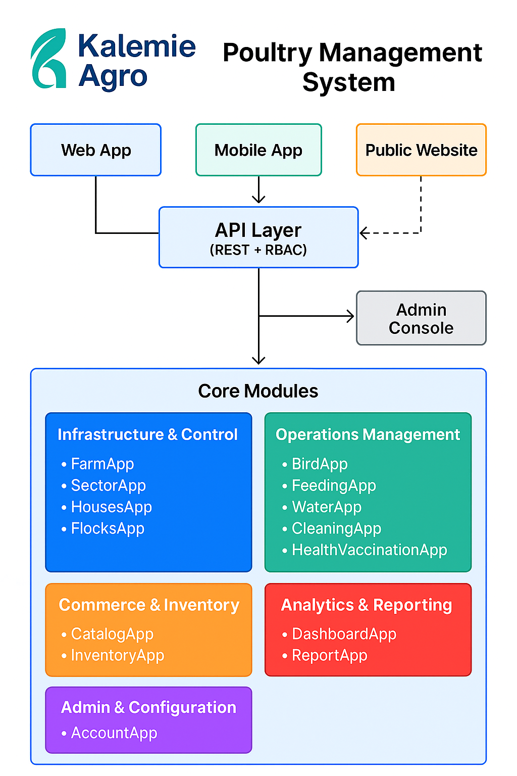

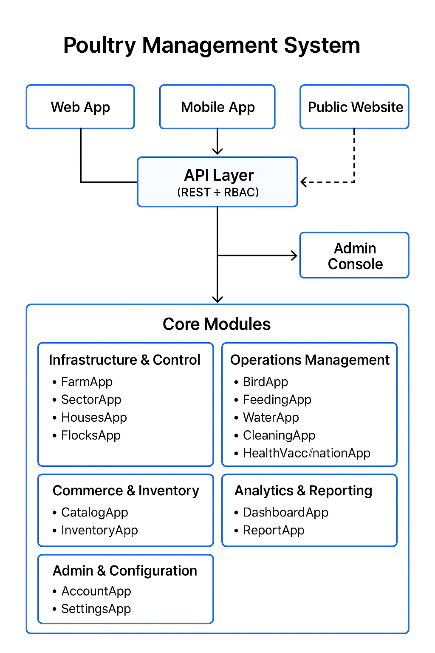

**🧱 Poultry Management System – Project Architecture**

**1. Presentation Layer**

* **Web App**: Admin dashboard, analytics, inventory, health tracking
* **Mobile App**: Field data entry, QR scanning, vaccination logs
* **Public Website**: Product showcase, order forms, impact stories (e.g., Kalemie Agro)

**2. API Layer**

* **Django REST Framework**
  + Token-based authentication
  + Role-Based Access Control (RBAC)
  + Endpoints for all modules (e.g., /api/inventory/, /api/dashboard/metrics/)

**3. Core Modules**

| **Category** | **Apps** |
| --- | --- |
| **Infrastructure & Control** | FarmApp, SectorApp, HousesApp, FlocksApp |
| **Operations Management** | BirdApp, FeedingApp, WaterApp, CleaningApp, HealthVaccinationApp |
| **Commerce & Inventory** | CatalogApp, InventoryApp |
| **Analytics & Reporting** | DashboardApp, ReportApp, NotificationApp |
| **Admin & Configuration** | AccountApp, SettingsApp |

**4. IoT Integration**

* Sensors for feed, water, temperature
* Data pushed to API → stored in FeedUsage, WaterConsumption, etc.

**5. Database Layer**

* PostgreSQL or MySQL
* Models for birds, flocks, inventory, health records, alerts

**6. Security & Access**

* RBAC middleware
* Admin, Supervisor, Field Agent roles
* Audit logs and notifications

**7. Deployment**

* **Backend**: Hosted on AWS, Heroku, or DigitalOcean
* **Frontend**: React (Web), React Native or Flutter (Mobile)
* **Public Site**: GitHub Pages or Vercel

Would you like me to:

* Generate a **visual diagram** of this architecture?
* Scaffold the Django project with these apps?
* Help you set up the **deployment pipeline**?

Let me know how you'd like to proceed!

I was generating a **visual architecture diagram** for your Poultry Management System project, based on the modular structure we discussed.

Let me try again now to generate a clean, well-labeled diagram showing:

* **Web App**, **Mobile App**, **IoT**, and **Admin Console**
* Flow through the **API Layer (REST + RBAC)**
* Core modules: Infrastructure, Operations, Inventory, Analytics, Admin

Would you like:

* A **portrait** or **landscape** layout?
* Icons or color-coded sections?

Let me know your preferences, or I’ll proceed with a clean **portrait layout**.

Create portrait layout diagram

Create landscape layout diagram

Add icons and colors